- Create one VPC,with 1 one public subnet and 1 private subnet.
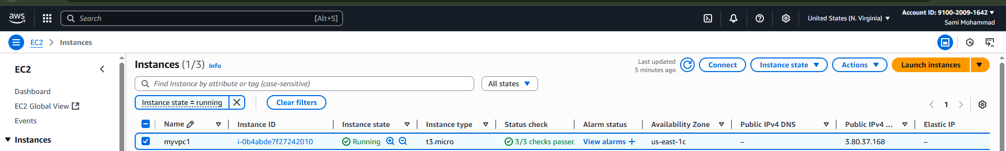
1 one public subnet and 1 private subnet.

- Enable VPC peering for cross region.

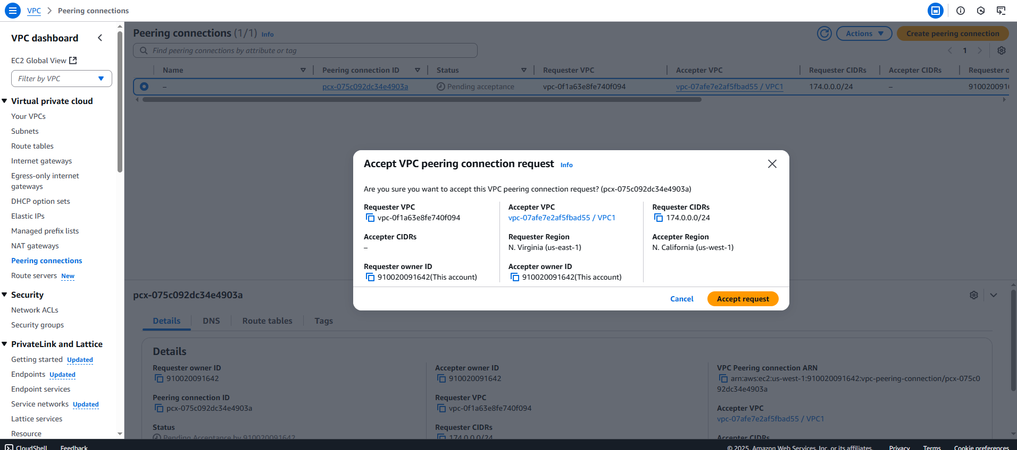
- Enable VPC peering for cross account. (You can collaborate with your friend and do this task).
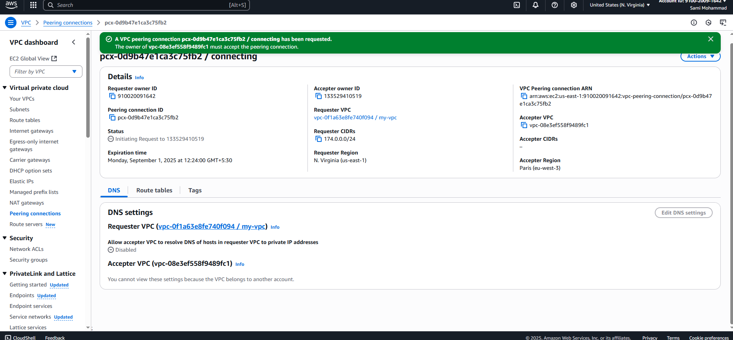

- Setup VPC Transist gateway.
Create VPCs
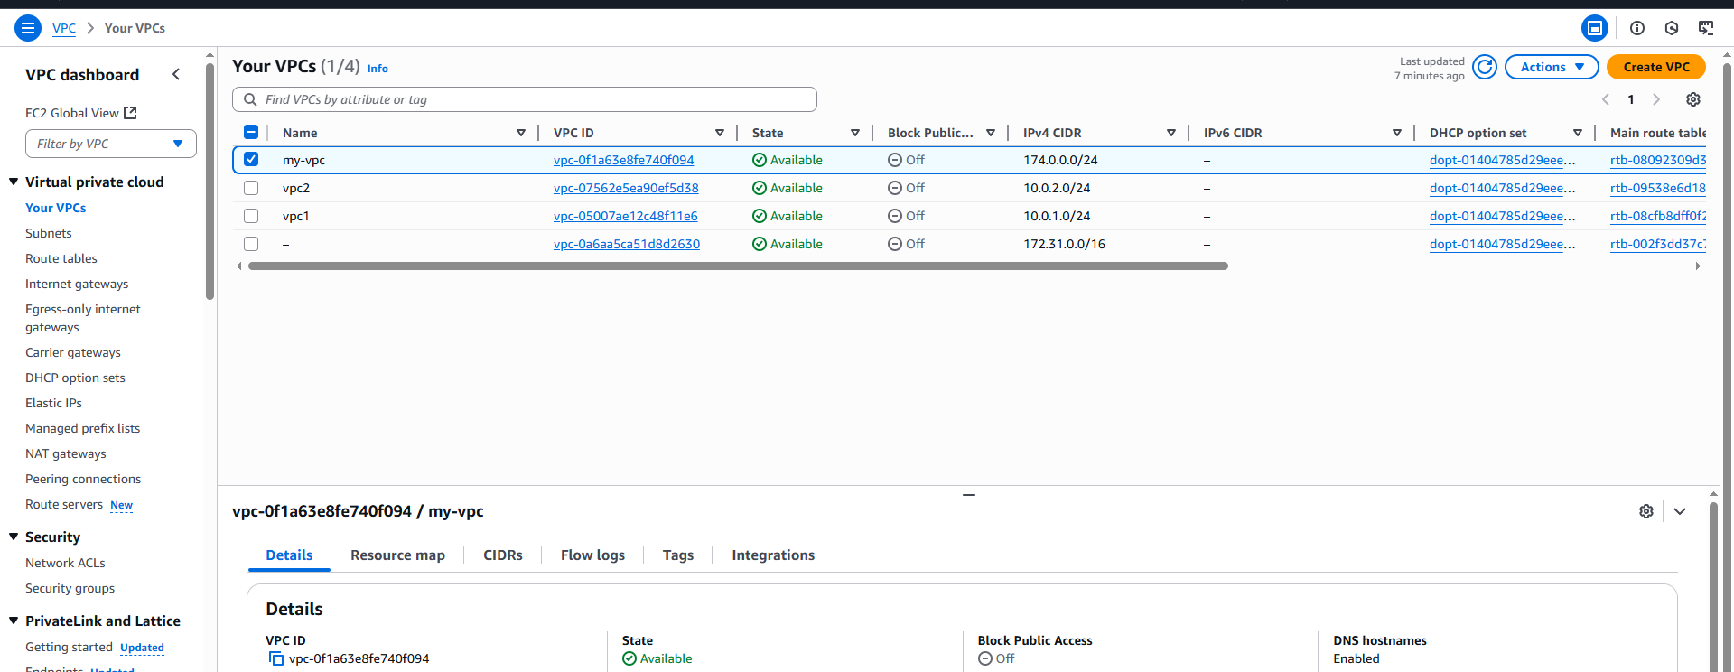
Create subnets
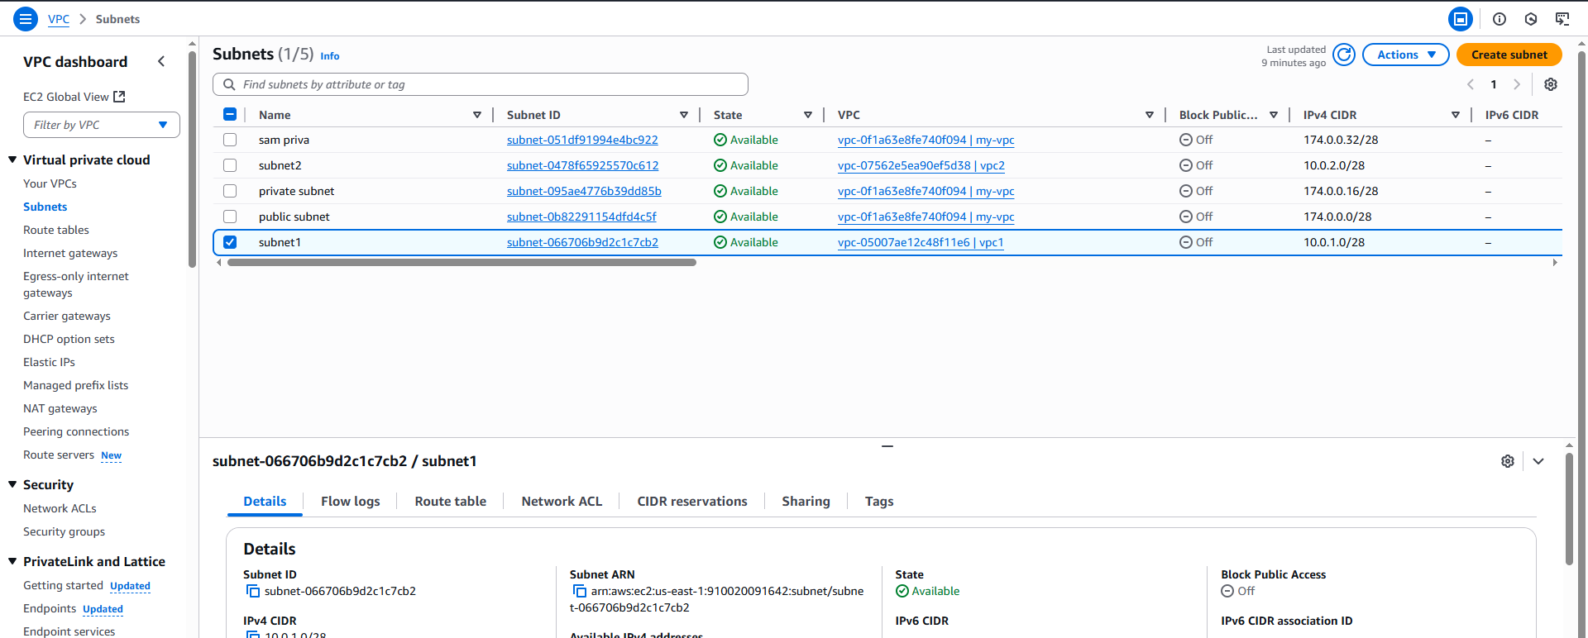

Go transit gateway create Transit gate way
After that give ASN number use default one in companies they will provide ASN no
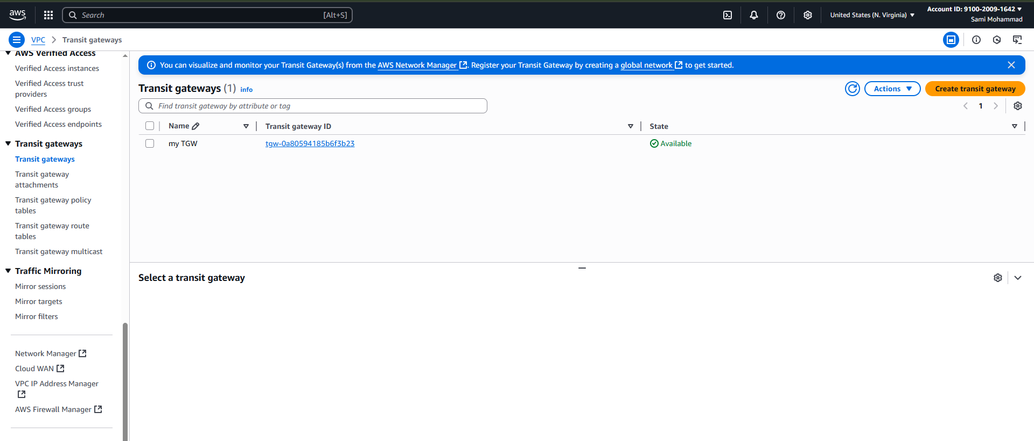

-lets created transit gateway attachment
Attach to VPC IDS
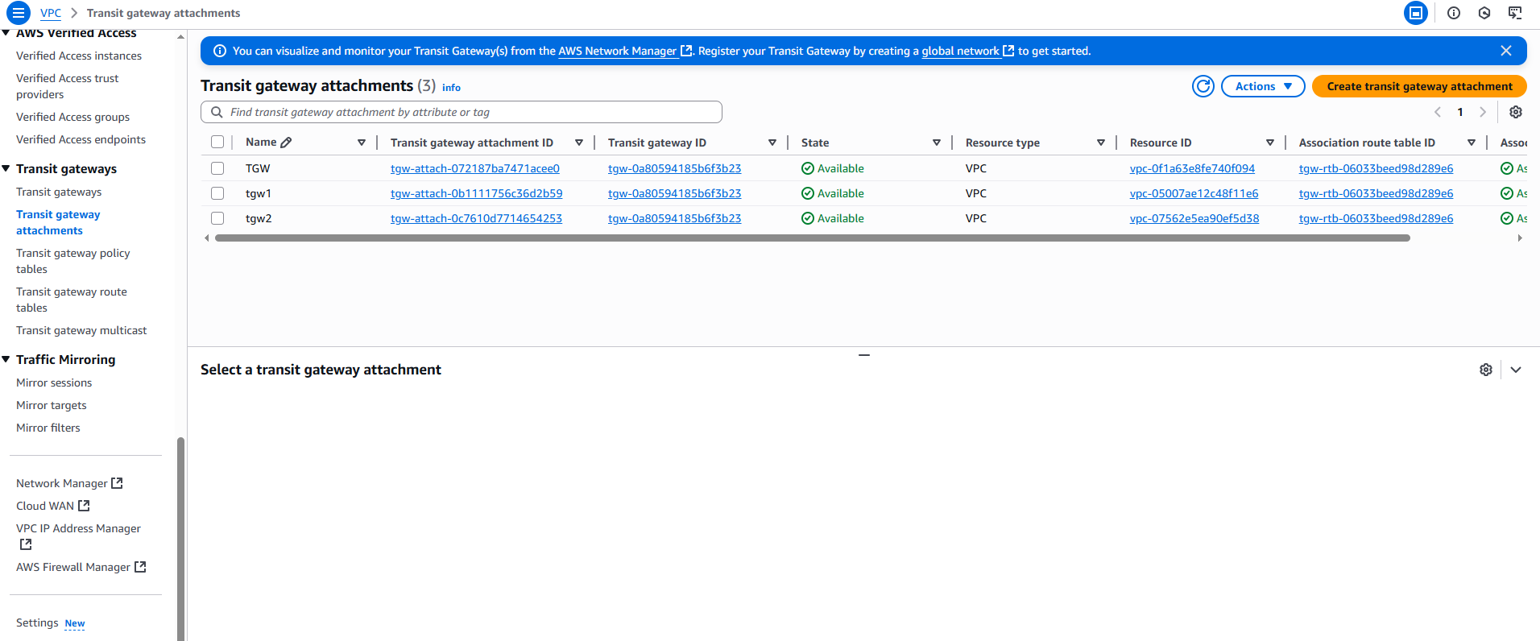
Create instances
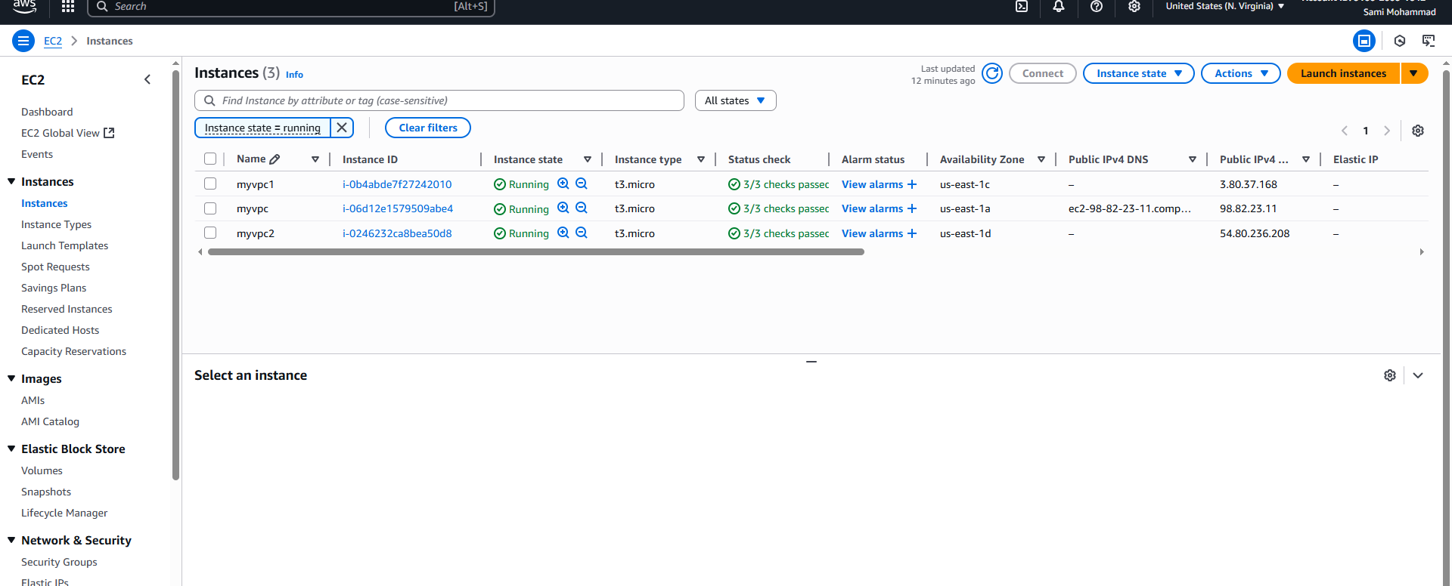

Lets connect myvpc1 to myvpc
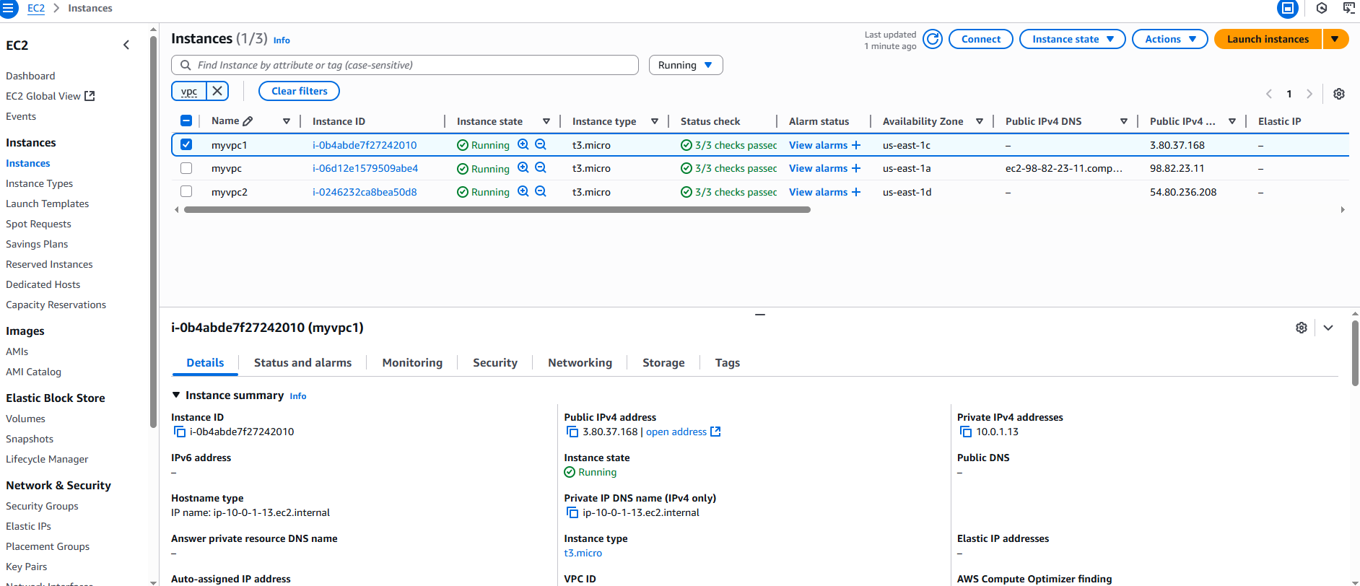
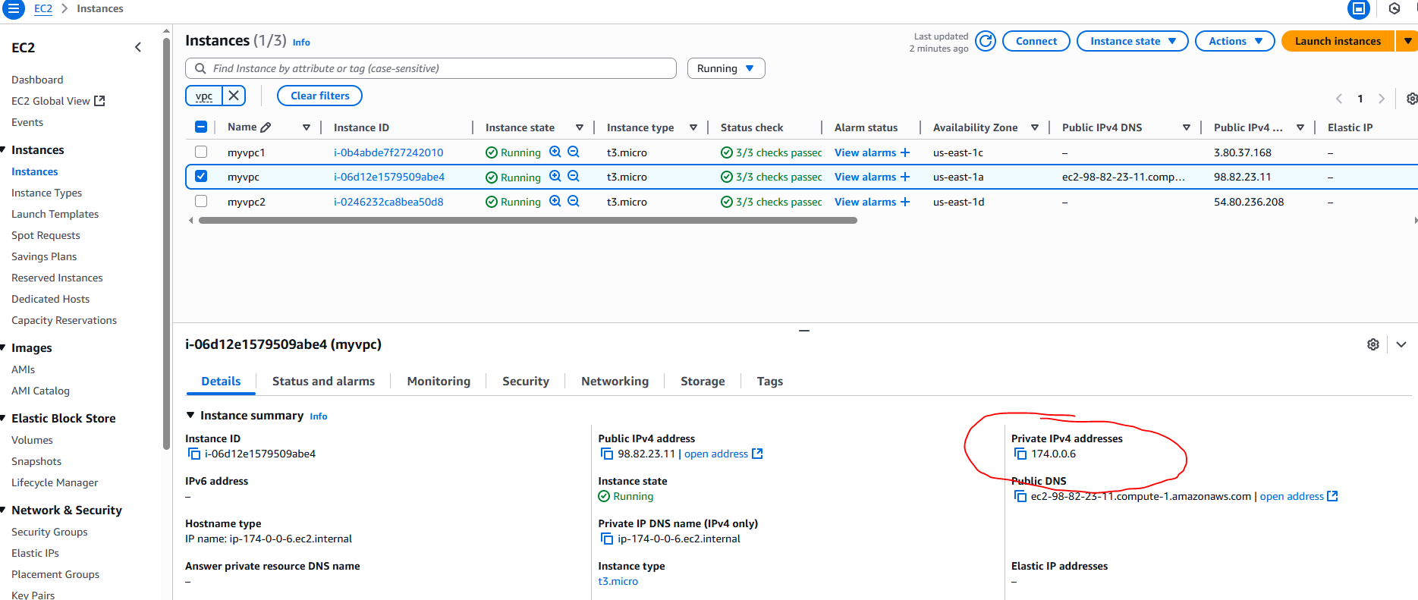
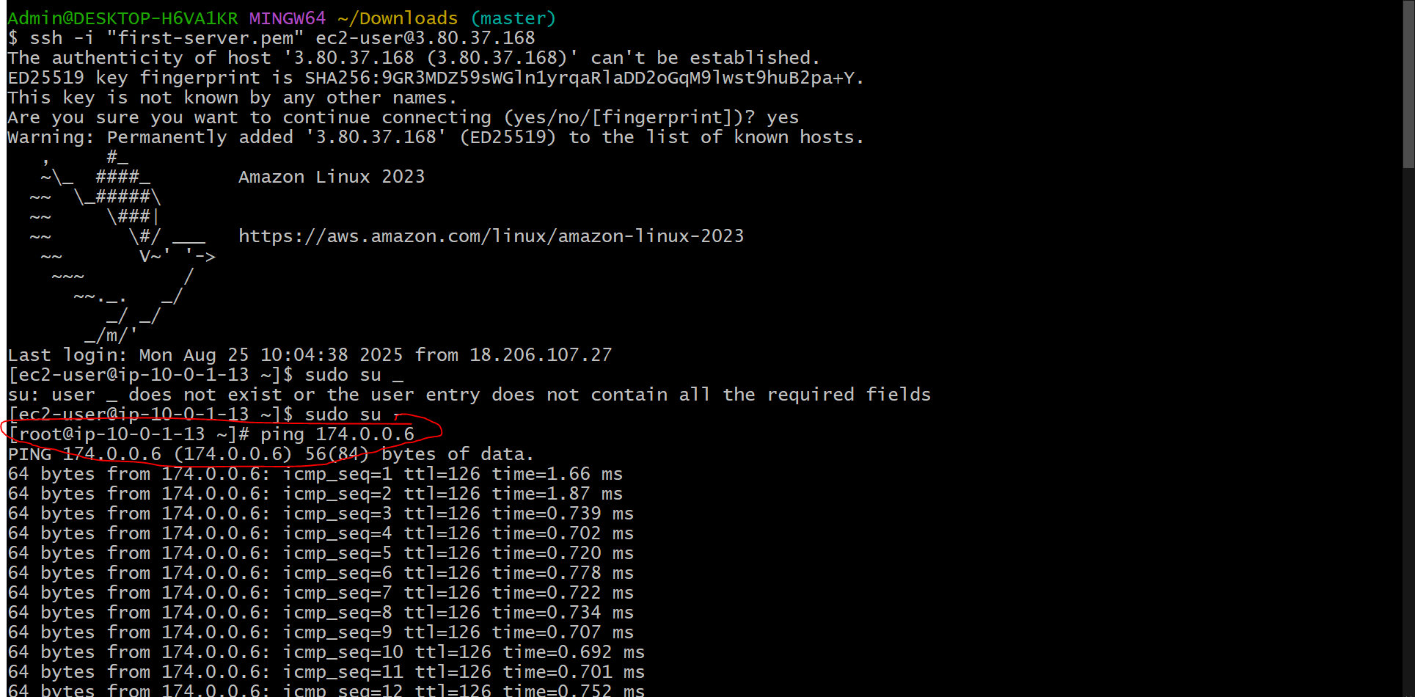

Similarly myvpc2 to myvpc1
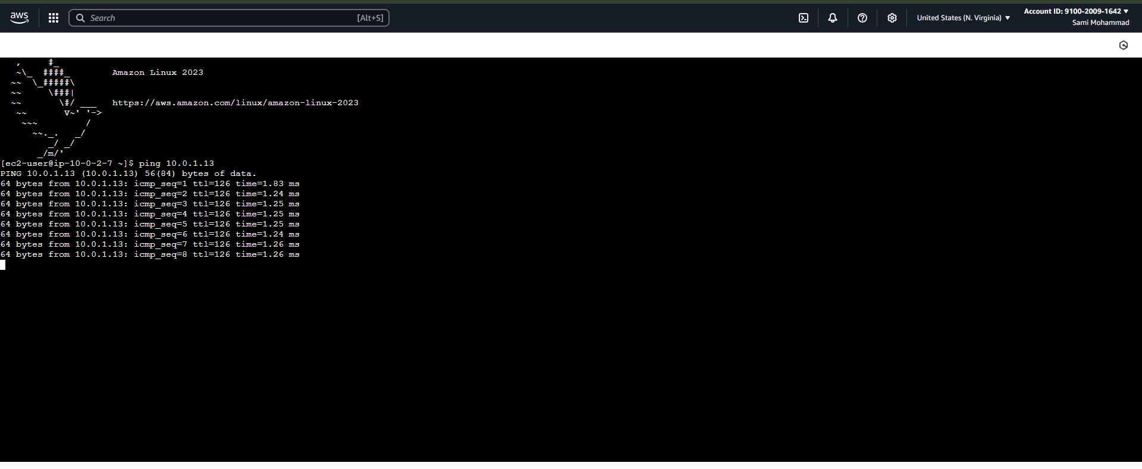
- Setup VPC End Point.
Create one vpc
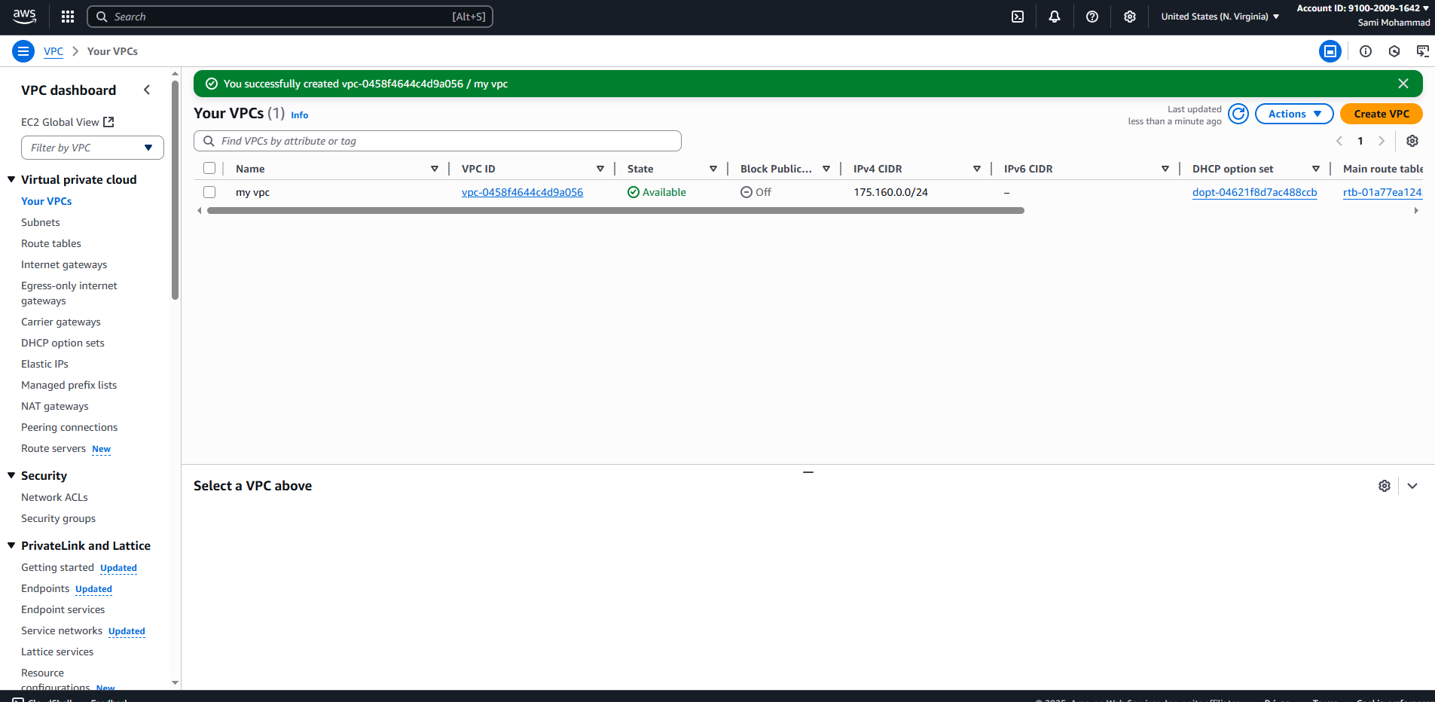
Create subnets one public & one private
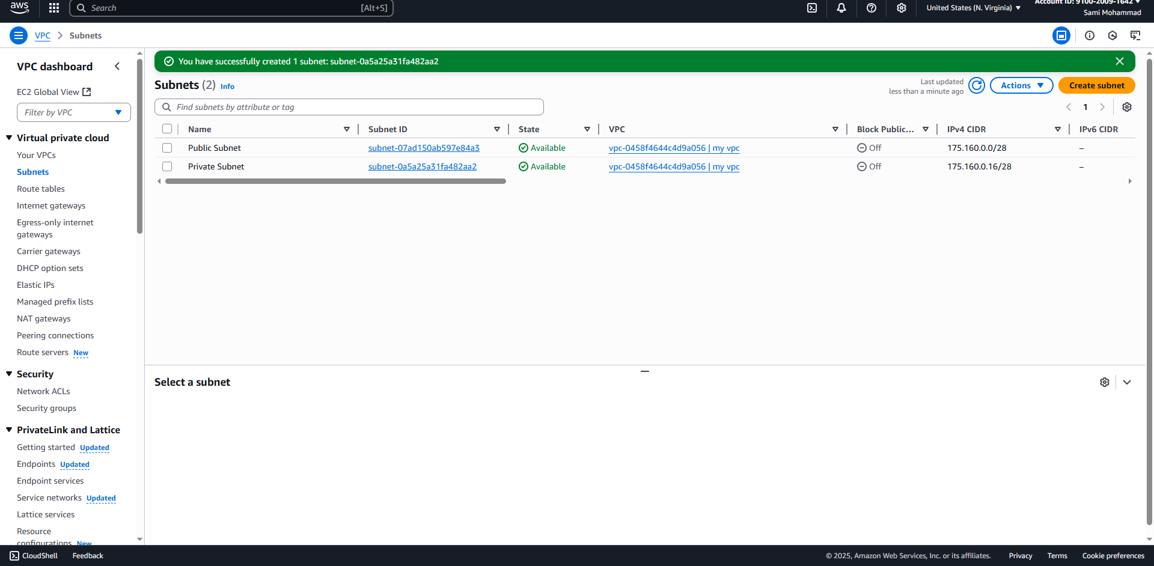

Connect through public subnet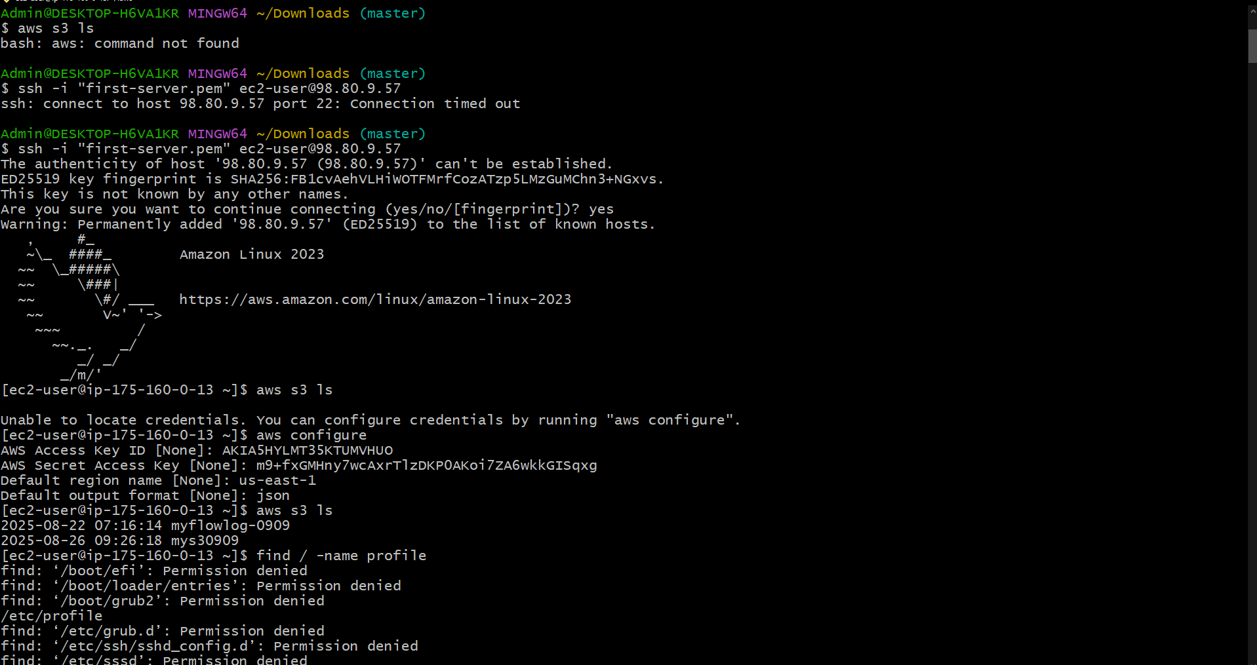
Connect to through private instance ec2 through Jump or baston server
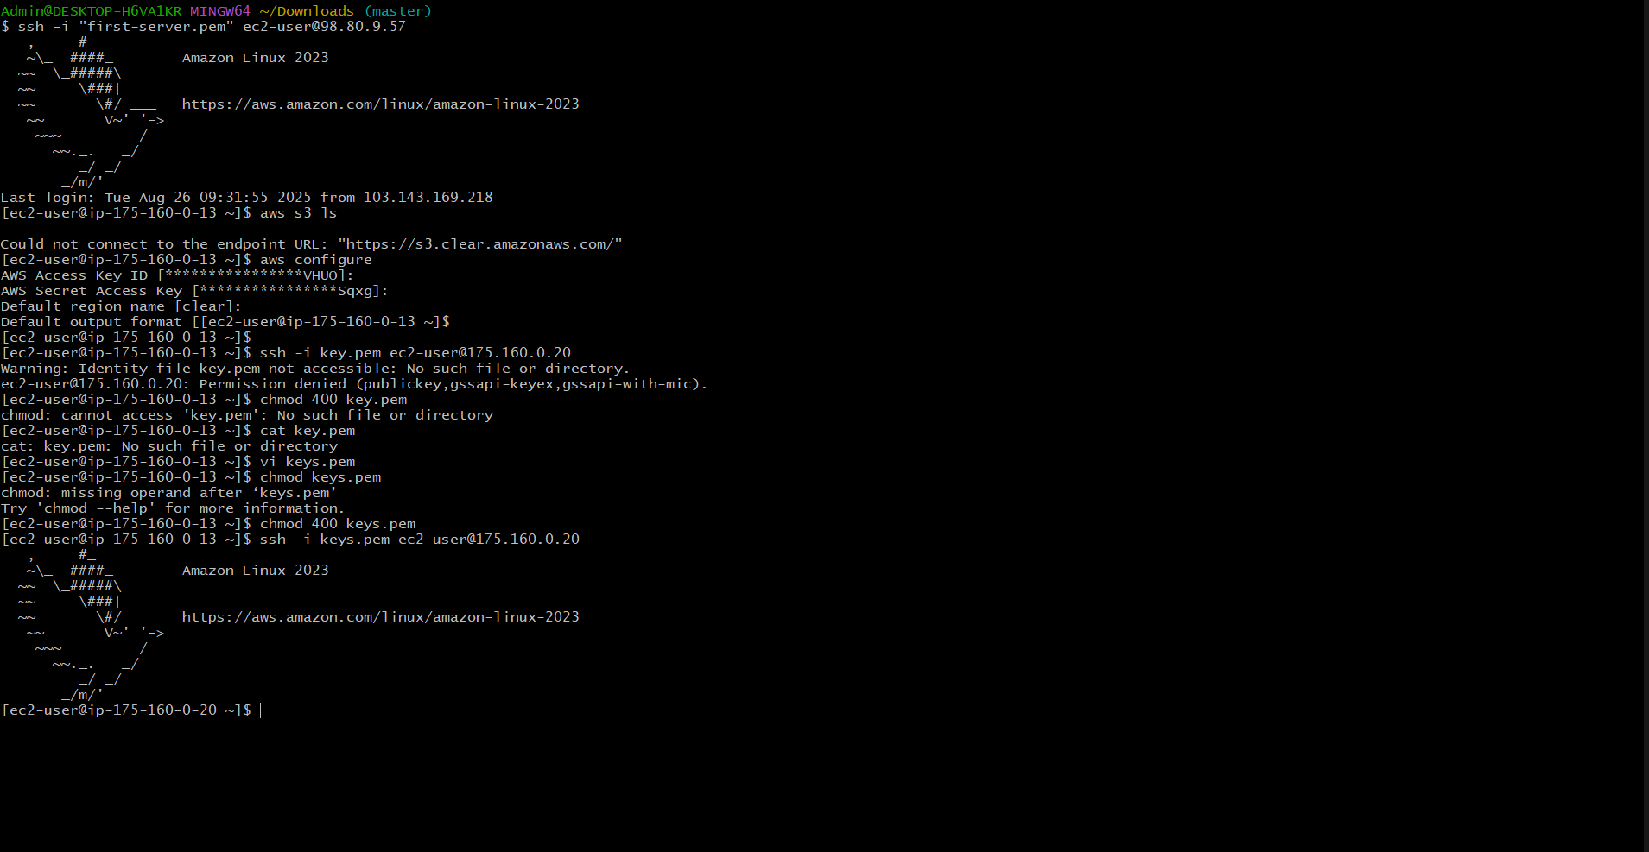
Create End Point